PART A- SYSTEM DOCUMENTATION
- Requirements Elicitation
Functional Requirements
- Customer Management
- Register new customers (individual & company).
- Login/ authentication for customers.
- Update customer details.
- Account Management
- Create accounts: Savings, Investment, Cheque.
- Savings: should be opened with P50.00 upon creation; deposits only; monthly interest (0.05%).
- Investment: requires initial deposits >= P500; deposits & withdrawals; monthly interest (5%)
- Cheque: requires employer info; deposits & withdrawals.
- Customers may hold multiple accounts.
- Transactions
- Deposit funds.
- Withdraw funds (where permitted).
- View transactions history.
- Record every successful transaction with timestamp and new balance.
- Interest Processing
- Monthly interest automatically applied to Savings & Investment accounts.
- Interest amount calculated from current balance and recorded as a credit transaction.
- Admin / Staff Functions
- Admin dashboard for viewing system stats, customer summaries, and generating reports.

INTERVIEW RECORD – BANKING SYSTEM
Interviewer: Ratang Thomas Manase
Interviewee (Client): Lecturer
Date: 18/09/2025
Location: Online via Teams

Q1. Should monthly interest require human approval before finalization or they should be fully automatic?
Response: It must be fully automated
Q2. Should there be a monthly statement set, after the system fully generates or automates that transaction?
Response: The system should automatically apply interest monthly, and this action should be recorded in the transaction history as credit/ deposit entry, showing amount of interest added and the new balance.
Q3. Beyond the basic details what customer information is most critical to store?
Response: Customers can be individuals or companies, and each has different critical details.. Some common (inherited) attributes across all customers;
Individual-specific attributes:
- Date of birth
- Next of Kin
Company-specific attributes:
- Company number
- Company address
- Ate of incorporation
- Authorized signatories
Q4. Clarification on the currency to be used
Response: Students can choose any currency (BWP, USD, etc.)
Q5. If a transaction fails, should there be something displayed on the screen?
Response: Yes, if a customer tries to withdraw more money than they have, the system must display an error message. In such cases no transactions should be recorded in the transaction history, Only successful transactions should be recorded.

Recording Link: OOAD Elicitation Session-20250918_103316-Meeting Recording.mp4

Non-Functional Requirements
- Security: Encrypted passwords; role-based access for staff; error handling for failed logins.
- Perfomance: Critical actions (login, deposit, withdraw) < 2 seconds under normal load.
- Usability: Clean JavaFX GUI; clear messages for errors (e.g. “Insufficient funds”).
- Scalability: design supports adding account types without major rewrite.
- Reliability: Atomic transactions; A transaction logging; backup strategy.
- Maintainability: MVC separation (Model, view, controller); use OOP best practices.
- Portability: Runs on Java runtime; DB layer abstract enough to support SQLite/ MySQL.

- Structural UML Modelling
  - System Use Case Diagram
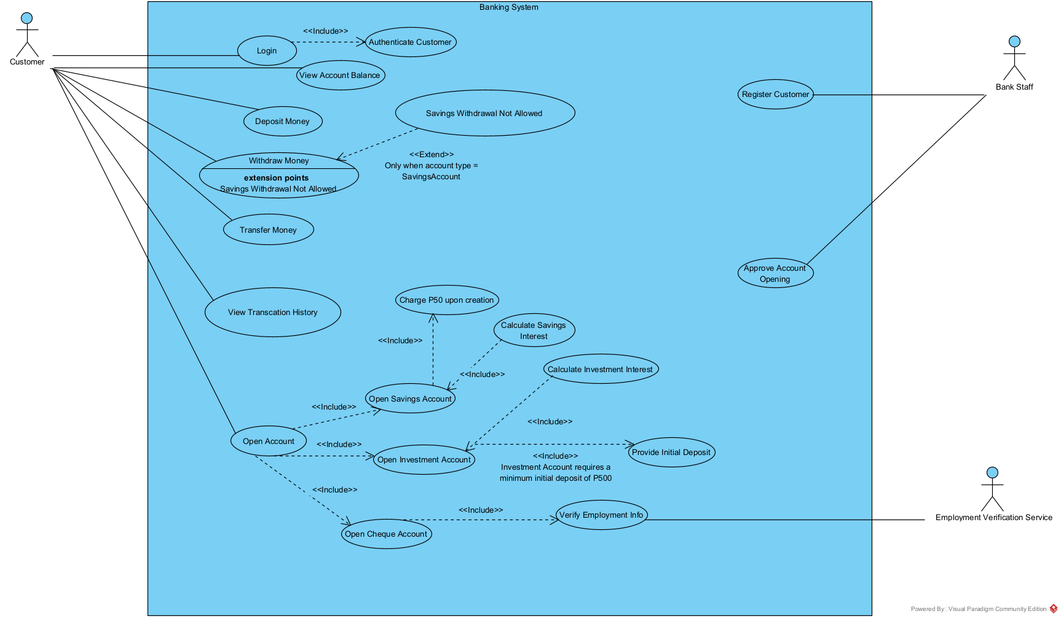
  - Class Diagram

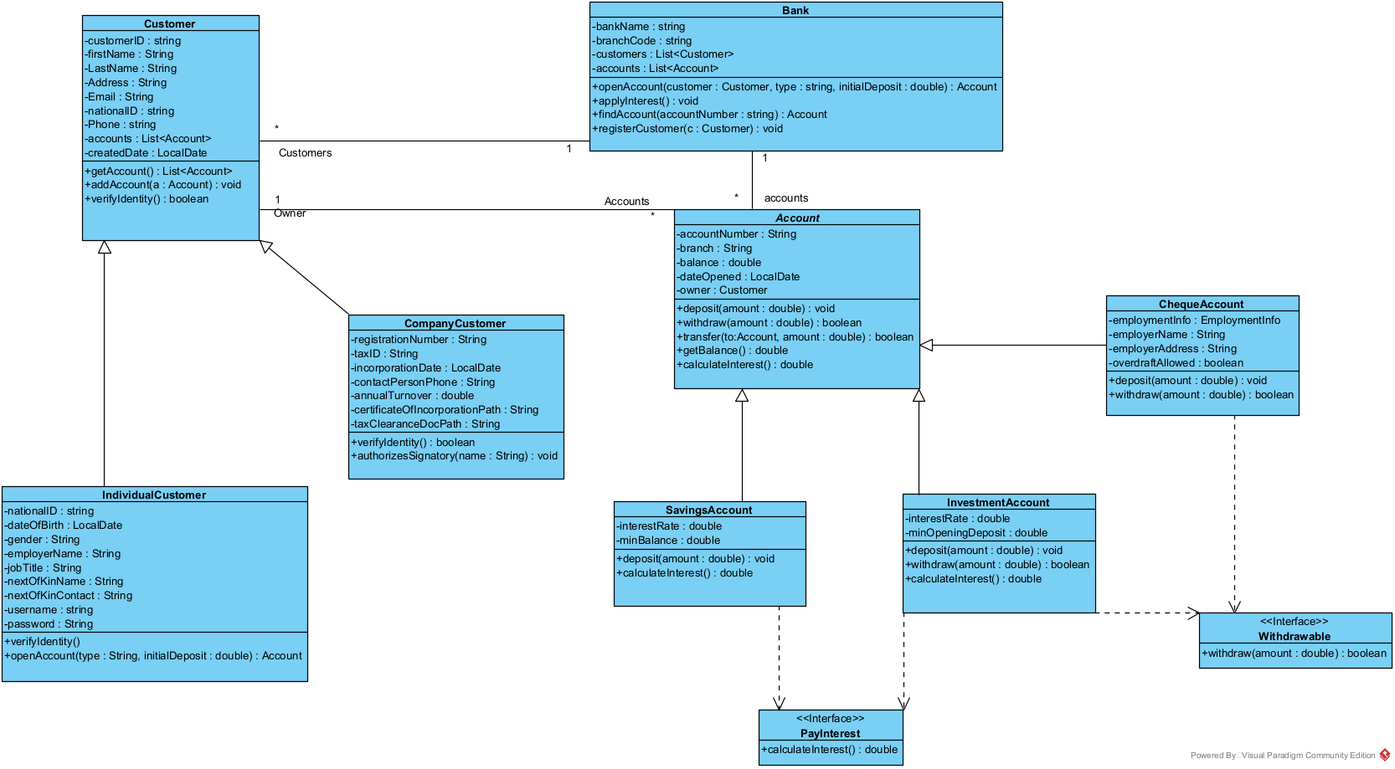

- Behavioural UML Modelling
  - Sequence Diagram
- Login Sequence Diagram
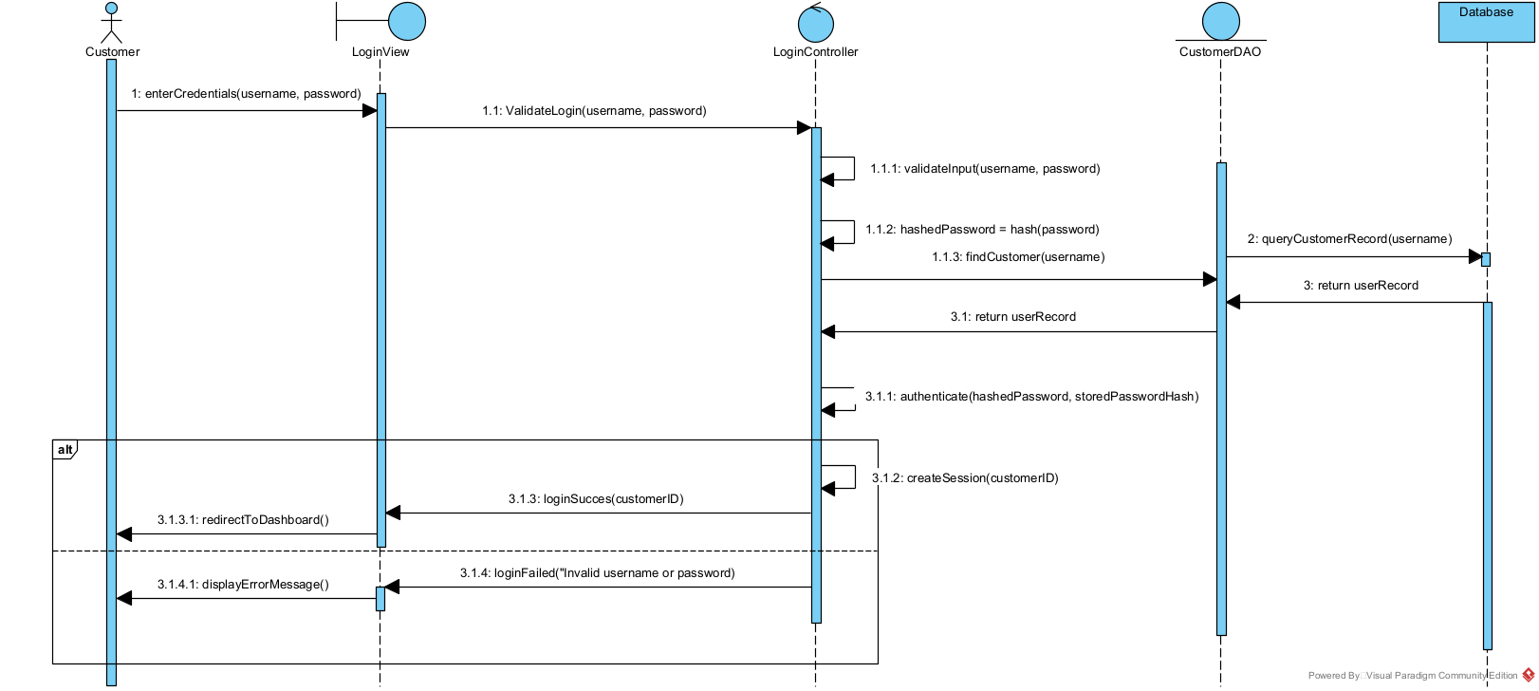
- Deposit Sequence Diagram
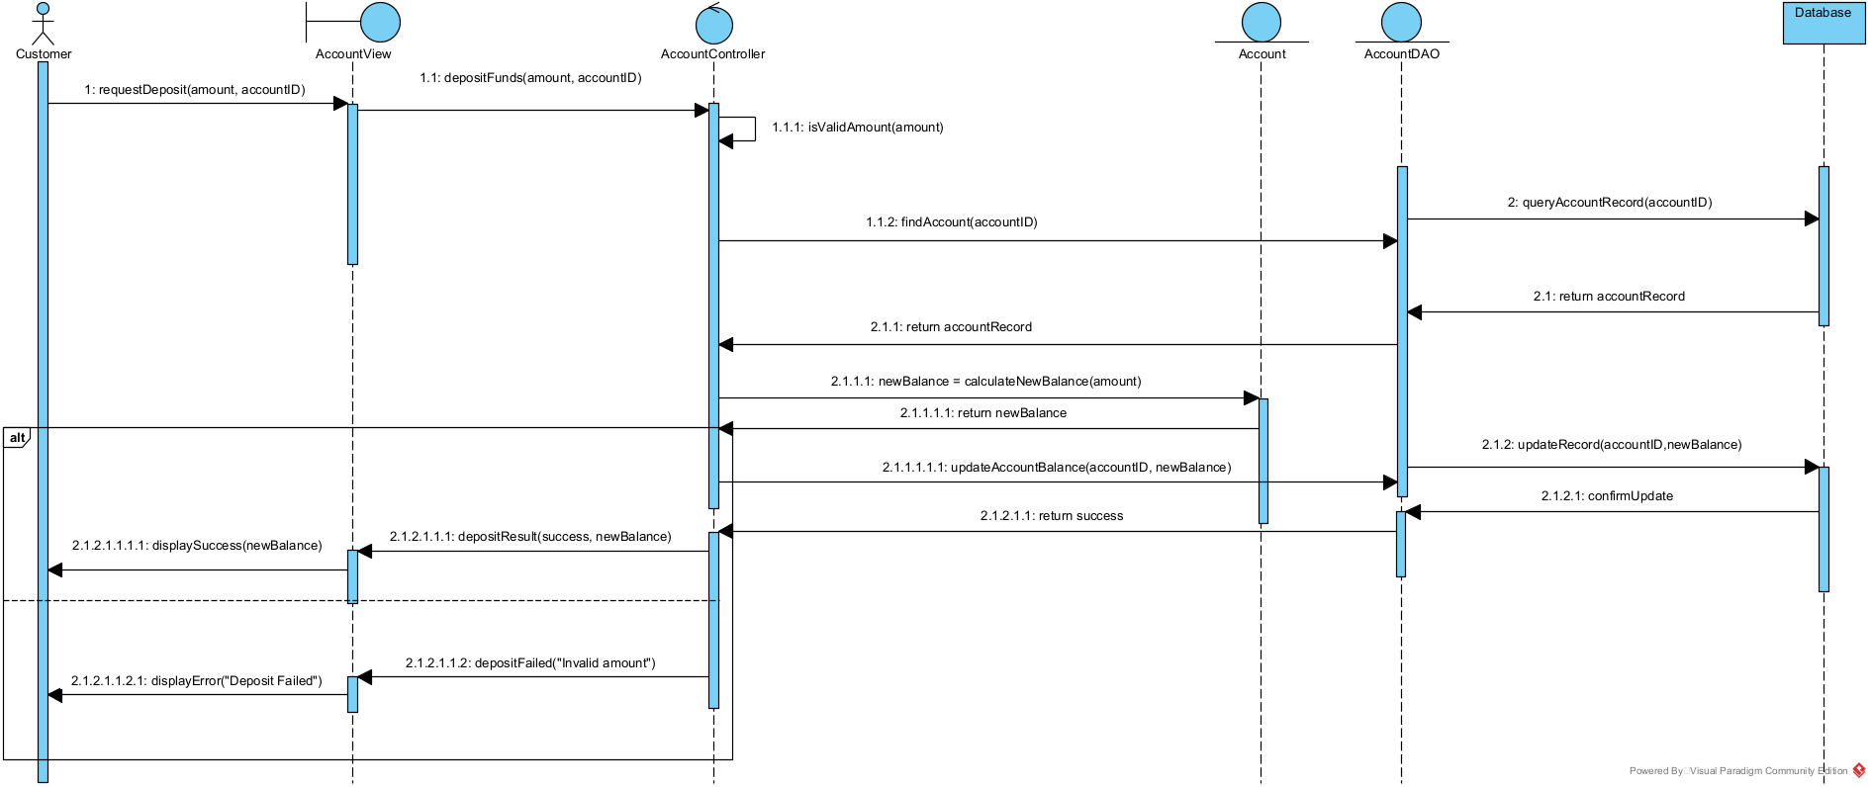

  - State Diagram – Pay Interest
  - 